New Office – Beginning March 1, 2014
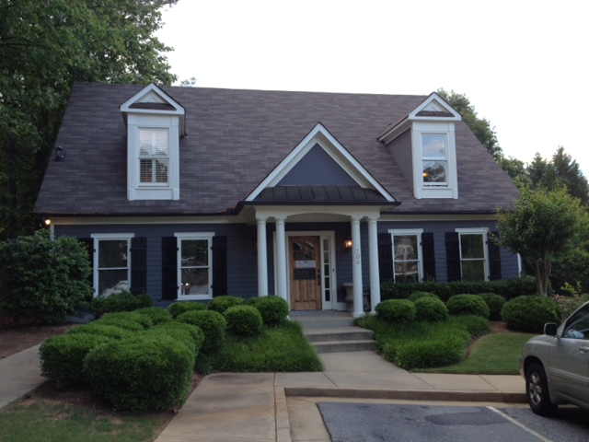
4985 Lower Roswell Road
Building 200
Marietta, GA 30068
Directions: MapQuest does NOT give accurate directions to my office at this time. Google Maps is more accurate. Please note that you must turn onto Noble Oak Drive from Lower Roswell Road to access our parking lot. After turning onto Noble Oak Drive, you will make an immediate left into the parking lot. We are located in Building 200 in the back of the property and on the first floor.
